Printing Type:-

1-Sublimation Printing

2-Spot Sublimation (ABP18 bag)

3-Vinyl Decal

4-Screen Printing

Jason Comment on trello: -https://trello.com/c/hEgIamtx

For all “Spot Sublimation”, we want the SUBLTR (artwork detail) and the SPPC (printing fee) to apply.

For all “Screen Printing”, the 1CLOGO, 2CLOGO, and 3CLOGO (artwork detail) and SPPC (printing fee) should apply.

**Printing Fee:**

**Printing fee will be zero: -** If product first Character **starts with “S”**, printing type is “Spot Sublimation” and “Sublimation Printing”

**Printing fee will be appear: -** If product first Character **not starts with “S”** and printing type is not “Spot Sublimation” and “Sublimation Printing”

Example

L2143, MBP13----Screen printing ---1CLTR, 1CLOGO

Otherwise we will pass customize detail for text “**1CLTR or 2CLTR or 3CLTR or 4CLTR**” (Pricing code) and For Logo **1CLOGO or 2CLOGO or 3CLOGO**

**SUBLTR**

If printing type is “Sublimation Printing” and “Spot Sublimation” then we will pass customise detail for text and logo etc. “**SUBLTR**” (pricing code)

In UB most of product starts with “S” their printing type is **Sublimation Printing** and **printing fee** will be 0 and for text and logo and image we will pass. “**SUBLTR**” (pricing code)

**Original Order No:-**

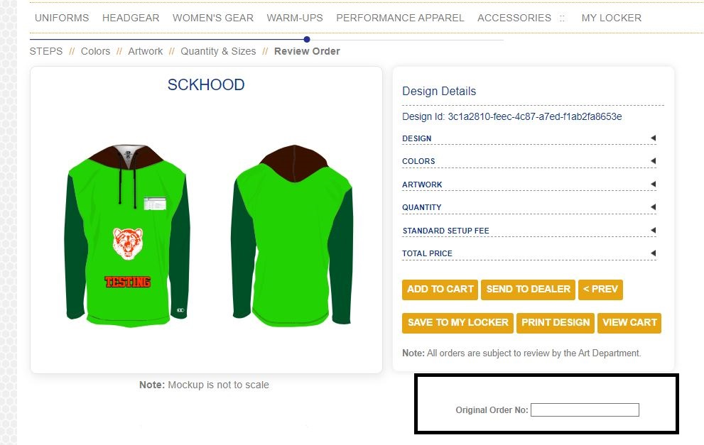

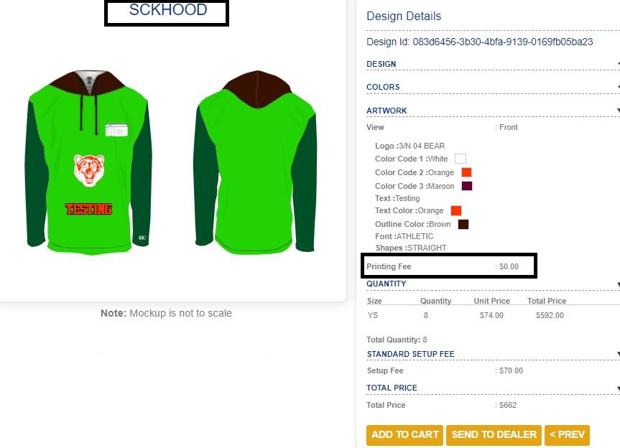

**addtockcart.asmx**

First parameter: - SCKHOOD-YS~8, SUBLTR~24, SPPC~1

Second parameter:-Product Image

Third parameter:- original order no

**In Cart or Add to card**

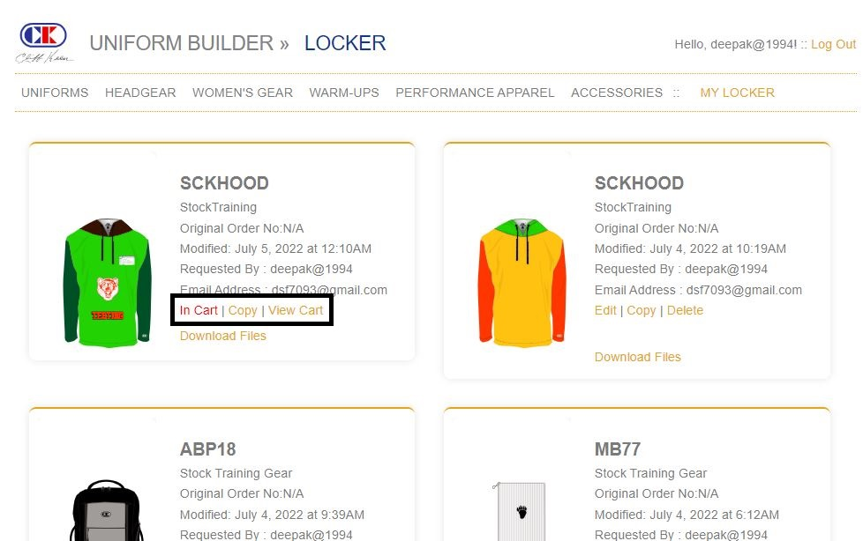

**View Cart in store end**

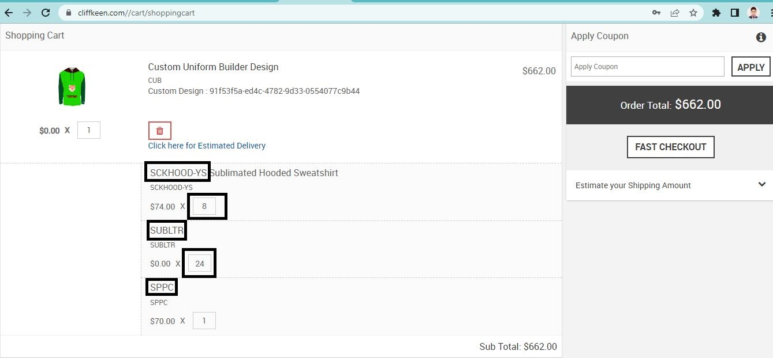

**With dealer (Send to Dealer)**

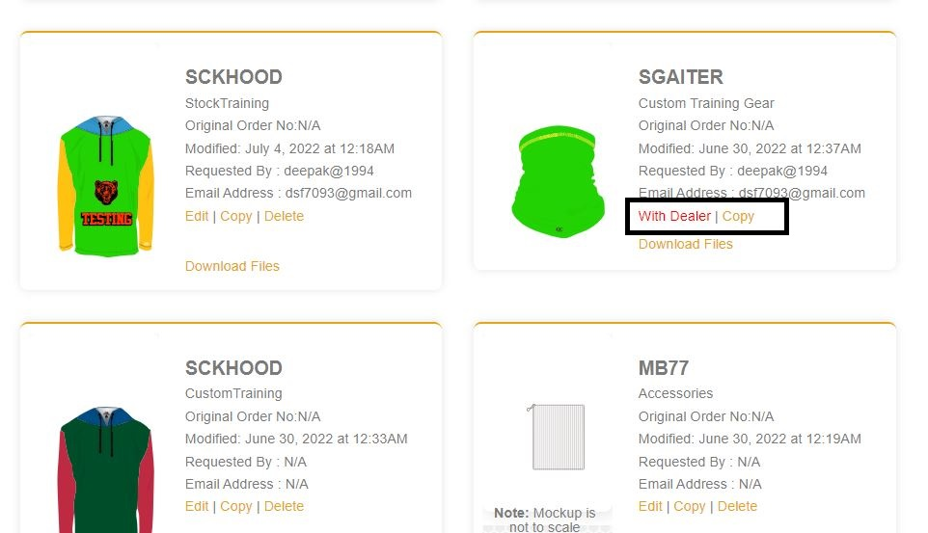

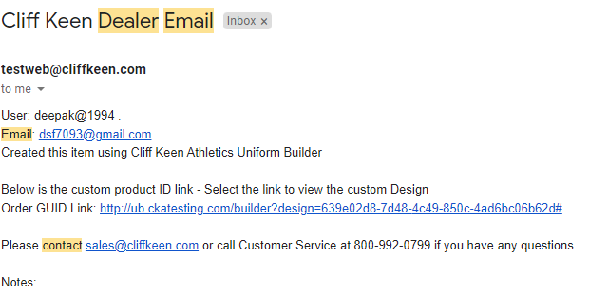

**Print Design**

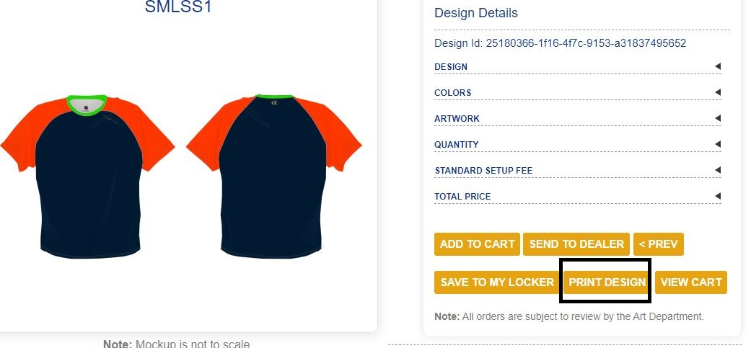

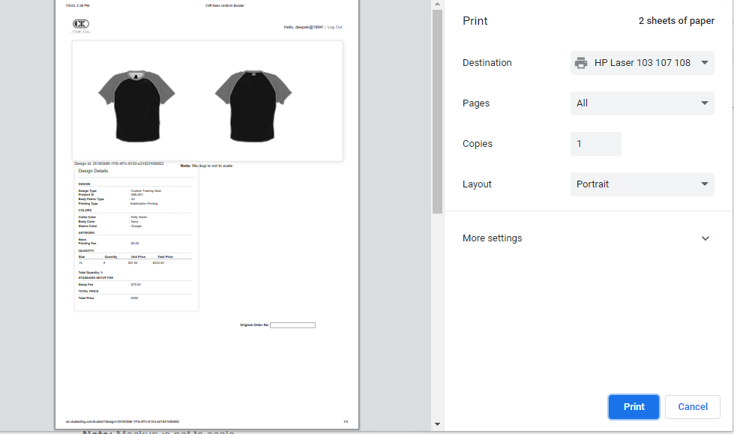

**Admin:-Edit Designs (Product selling priority)**

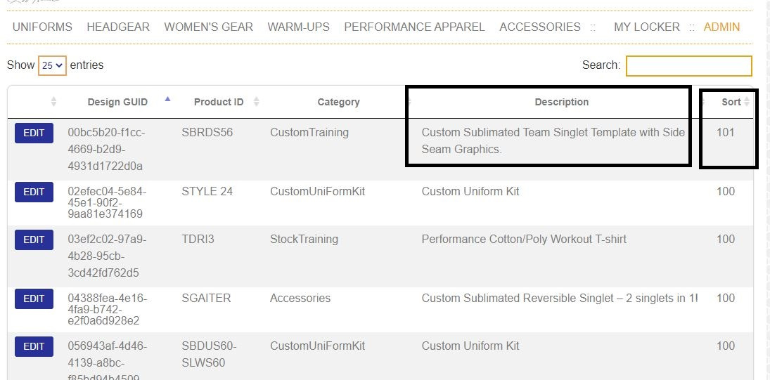

**Edit Dealers**

Import and Export Functionality.

**Manage Design**

Show all “add to cart” and “send to dealer” products

**Manage Request**